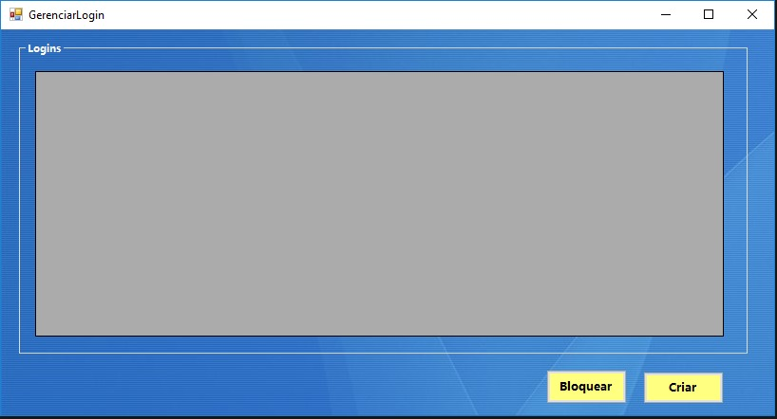

|  |  |  |  |  |
| --- | --- | --- | --- | --- |
| **CT NO.** | **PROPOSITO** | | | |
| **1** | **VERIFICAR SE CRIARÁ O LOGIN** | | | |
| **PRÉ-CONDIÇÕES** | | | | |
| **Não tem** | | | | |
| **ENTRADA 1** | | **ENTRADA 2** |  |  |
| **CRIAR**  **BLOQUEAR** | | **TABELA** |  |  |
| **SAÍDAS ESPERADAS** | | | | |
| **LOGIN CRIADO** | | | | |

|  |  |  |  |  |  |
| --- | --- | --- | --- | --- | --- |
| **TESTE No.** | **BOTAO** | **TABELA** |  |  | **SAIDA ESPERADA** |
| **1** | **CRIAR** | **USUARIO01** |  |  | **LOGIN CRIADO** |

|  |  |  |  |  |  |
| --- | --- | --- | --- | --- | --- |
| **TESTE No.** | **BOTAO** | **TABELA** |  |  | **SAIDA ESPERADA** |
| **2** | **BLOQUEAR** | **USUARIO01** |  |  | **USUARIO BLOQUEADO** |

|  |  |  |  |  |  |  |
| --- | --- | --- | --- | --- | --- | --- |
| **Aplicado em** | **Aplicado**  **por** | **Quantidade**  **de falhas** | **Depurado por** | **Reaplicado**  **em** | **Reaplicado**  **por** | **Quantidade**  **de falhas** |
|  |  |  |  |  |  |  |